Content Page Template

This template is used for All the static pages.

Basic Tab

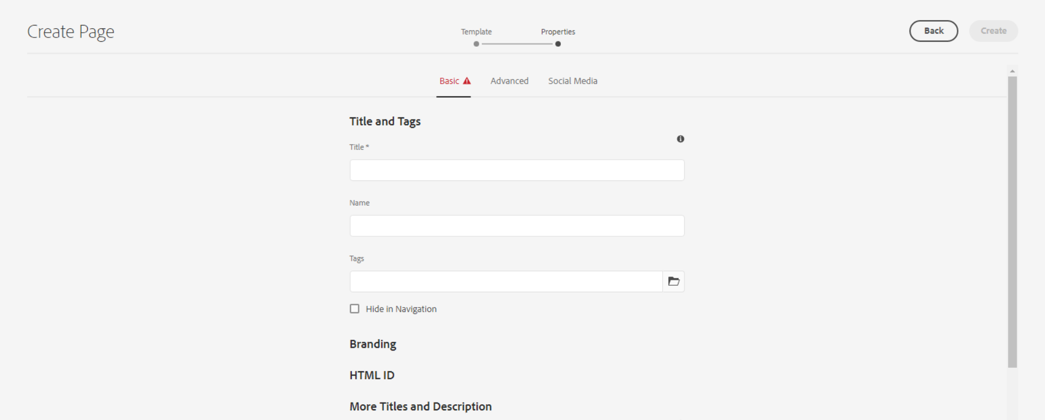

**Title** – Defines the page meta title for SEO, as well as a title displayable in the page content (unless an overriding 'Page Title' is defined).

**Name** – It should be the page name.

**Tags** – Defines the page meta tag for SEO

**Checkbox for Hide in Navigation** – This is for hide the page from header navigation.



**Page Title** - Defines a page title that is displayable in the page content, instead of the 'Title'.

**Navigation Title** - Defines a navigation title that is displayed in site navigation menus, instead of the 'Page Title' or 'Title'.

Advanced Tab

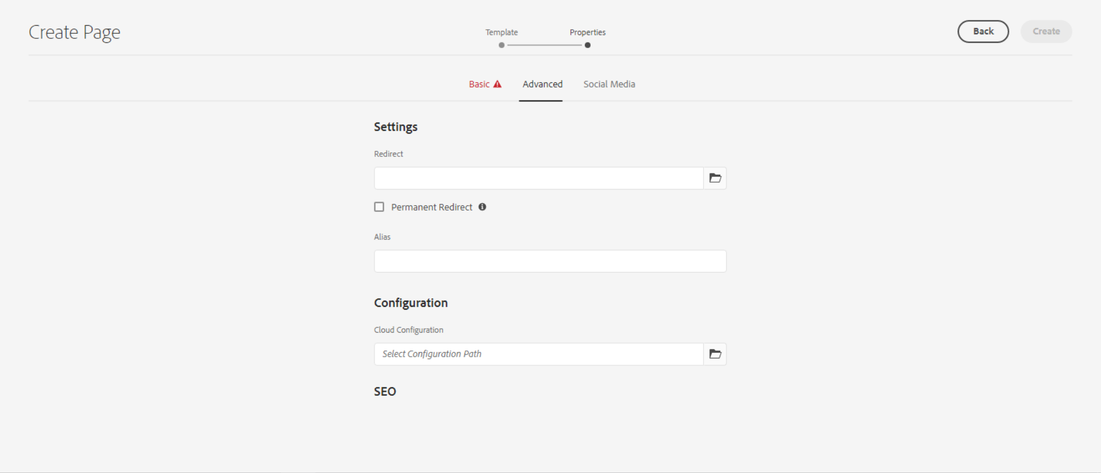

**Redirect** – Here we can set the internal or external redirect path

**Checkbox for Permanent Redirect** – can be checked to enable Permanent Redirect.

Social Media Tab

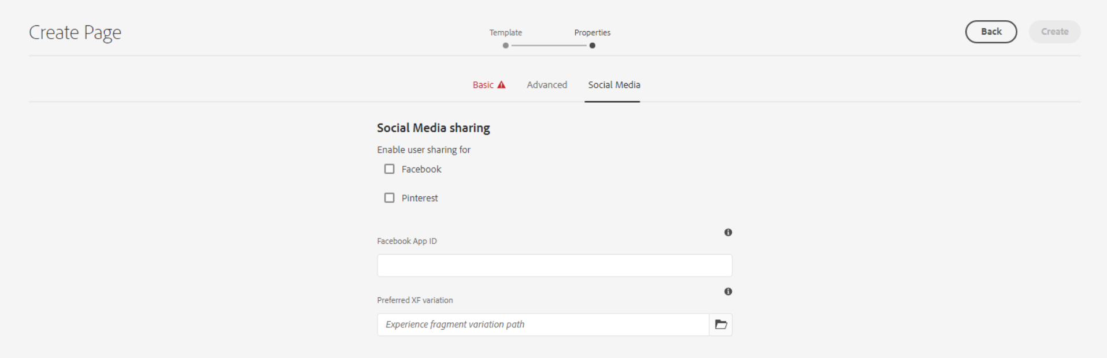

This is for social media Sharing.

Thumbnail Tab

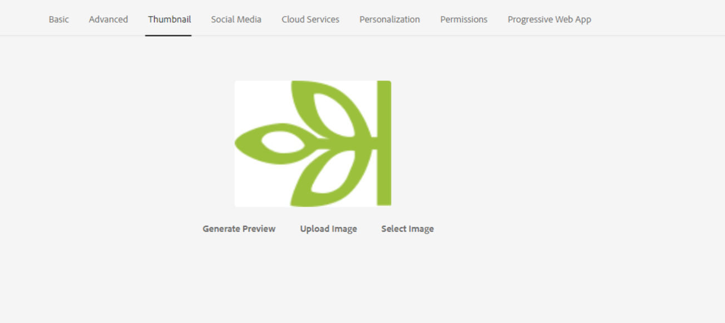

Here we can add or upload thumbnail image of the page.